Southeastern European Regional Programming Contest
Bucharest, Romania
October 19, 2002



Problem D
Art Gallery

Input File: D.DAT
Program Source File: D.PAS or D.C or D.CPP or D.JAVA

The art galleries of the new and very futuristic building of the Center for Balkan Cooperation have the form of polygons (not necessarily convex). When a big exhibition is organized, watching over all of the pictures is a big security concern. Your task is that for a given gallery to write a program which finds the surface of the area of the floor, from which each point on the walls of the gallery is visible. On the figure 1. a map of a gallery is given in some co-ordinate system. The area wanted is shaded on the figure 2.

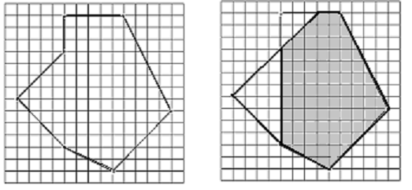

Input
The number of tasks T that your program have to solve will be on the first row of the input file. Input data for each task start with an integer N, 5≤N≤1500. Each of the next N rows of the input will contain the co-ordinates of a vertex of the polygon – two integers that fit in 16-bit integer type, separated by a single space. Following the row with the co-ordinates of the last vertex for the task comes the line with the number of vertices for the next test and so on.

Output
For each test you must write on one line the required surface - a number with exactly two digits after the decimal point (the number should be rounded to the second digit after the decimal point).

Sample Input Sample Output
1 80.00
7
0 0
4 4
4 7
9 7
13 -1
8 -6
4 -4

